STERILISING RESEARCH & ADVISORY COUNCIL OF AUSTRALIA SA Inc
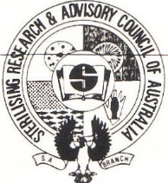
ANNUAL GENERAL MEETING
WEDNESDAY 15th SEPTEMBER 2021
THE ARKABA HOTEL
50 GLEN OSMOND ROAD
FULLARTON 5063
1800 - 2030

PLEASE NOTE: CARPARKING AVAILABLE ON SITE
ALSO AT WOOLIES (ignore posted time frames at that time)
1800 Nibbles & Networking
1845 Introduction by Invitro Technology
1900 Presidents Welcome
1910 AGM (Returning Officer )
Present & Apologies
Acceptance of Previous Minutes (19 August 2020)
Presidents Report
Treasurers Report
New Business
Ballot for new Committee Members
This Photo by Unknown Author is licensed under CC BY-NC-ND
1930 Guest Speaker: TBC
Nicole Kerkemyers –
Wellness and Resilience

2045 Introduction of New Committee Members

2100 CLOSE
PLEASE RSVP YOUR ATTENDANCE NO LATER THAN
Wednesday 8th September 2021
to: renee.pringle@acha.org.au or dora.gadaleta@sa.gov.au
renee.pringle@acha.org.au OR dora.gadaleta@sa.gov.au

